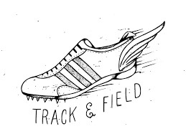

# FREE Sports Physicals at Heights

# School for school year 2023-2024

When: Monday 06/12/2023 and Monday 07/10/2023

Time: 8:30 am

Where: Heights High School Gym

Host: Hogg Clinic Phone #713-864-7614

Don’t miss out on the FREE Sports Physicals!!!

Sign up with Coach Dixon or contact Hogg clinic

